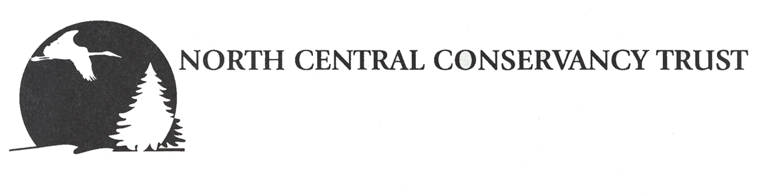
301 W Cedar St, Stevens Point, WI 54481
https://www.ncctwi.org/

EXECUTIVE DIRECTOR POSITION DESCRIPTION

OVERVIEW North Central Conservancy Trust’s (NCCT) mission is to conserve the natural heritage of Central Wisconsin through the protection of land. To further this mission, NCCT has adopted the following four strategic objectives: protecting land through conservation easements and strategic acquisitions; properly stewarding our protected land; building a strong organization that is prepared to carry out its land protection mission in perpetuity; and engaging community to promote the conservation of land.
NCCT serves Adams, Clark, Lincoln, Marathon, Portage, Taylor, Waushara and Wood Counties. NCCT’s conservation work has historically been supported by volunteers who are experts in the natural resource fields, including faculty from the University of Wisconsin-Stevens Point, College of Natural Resources.
SUMMARY OF POSITION NCCT seeks a dynamic individual to build on our financial strength and lead the organization into its next chapter. This position presents a challenging opportunity to design and implement a plan that broadens our base of donors and supporters while leading the organization through the Land Trust Alliance’s accreditation program.
As the principle spokesperson of NCCT, the Executive Director must display the highest standards of professionalism, cooperation and integrity and maintain positive relationships with landowners, funders, members of the community and our many conservation partners. The Executive Director will coordinate and oversee all land trust operations, provide leadership and staff supervision to support the achievement of NCCT’s mission. The Executive Director will work closely with the Board of Directors to ensure the financial health of the organization and will monitor and report progress to the Board and standing committees. This position oversees the day-to- day activities of the organization and the management of the organization’s office, budget, staff and properties, as well as its land acquisition, community outreach and fundraising activities. This position provides leadership and support to the Board of Directors and is under the direction supervision of the Board President and reports to the Executive Committee.
This is a full-time salaried position and will require occasional evening and weekend hours and travel.
REQUIRED QUALIFICATIONS
- BA/BS degree and a minimum of five years of experience in land trust work, natural resource management, non-profit management, or a related field.
- Three years of supervisory or equivalent experience.
- Demonstrated successful experience developing and implementing fundraising strategies, annual campaigns, and managing a budget.
- Articulate and enthusiastic communicator, both written and verbally.
- Leadership experience, ability to set a clear vision and to create and thrive independently and in a team environment.
- Strong organizational skills.
- Demonstrated ability to think strategically, develop, manage, and evaluate complex projects from to start to finish and ability to adapt to changing circumstances.
- Working knowledge of common software applications (Word, Excel, PowerPoint, Web browsers) and willingness to learn new software programs.
- Ability to work on a flexible schedule; availability to work some evenings and weekends.
- Valid driver’s license and own transportation.
PREFERRED QUALIFICATIONS
- MA/MS degree and a minimum of five years of experience in land trust work, natural resource management, non-profit management, or a related field.
- Familiarity working in rural communities.
- Deep commitment to the conservation of wildlife habitat and rural working landscapes.
- Ability to work effectively with volunteer boards, committees, landowners, community groups, and conservation partners to achieve shared objectives.
- Knowledge and experience with the policies and tools of voluntary private land conservation and conservation finance.
- Finely tuned negotiation and collaboration skills.
- Prior work in land conservation.

RESPONSIBILITIES INCLUDE BUT ARE NOT LIMITED TO:
STRONG ORGANIZATION Participate as a nonvoting member of the Executive and Finance Committees to oversee the organization’s financial and administrative activities.
Fundraising
- The Executive Director has the lead responsibility for raising the operating and capital funding necessary to support NCCT’s mission.
- Work with the NCCT Board and related committees and supervise and work with the Outreach Coordinator to oversee the development of a fundraising program, solicit major gifts, coordinate donor recognition activities, and cultivate donor relationships.
- Develop and implement fundraising activities including solicitation of donors and grants, membership development, and assisting the Board in cultivating donors.
- Foster local support for the conservation of wildlife habitat, agricultural landscapes, and open spaces.
General Administration
- Assist in the development of annual budgets and work plans.
- Work with NCCT’s accountant to maintain and operate financial and record-keeping systems.
- Maintain corporate records and ensure sufficient redundancy of legal documents and other important records.
- Provide guidance to Board and committees on compliance and accreditation under LTA Standards and Practices.
- Supervise employees (currently one) and inspire them to excel in their respective areas of expertise while providing ongoing mentoring, guidance, and tools they need to succeed.
- Oversee contractors and consultants of the organization.
Organizational Development
- Serve as a direct line of communication to the Board of Directors. Monitor and report to the Board regarding progress of the organization.
- Assist the Board and committees in recruitment and training of new board and committee members.
- Cultivate, maintain and support a strong Board of Directors and build board involvement with strategic direction.
- Actively support staff and board development.
- Develop and maintain appropriate relationships with local, regional and state collaboratives and with other agencies, groups and organizations.
PROTECTING LAND
- Participate as a nonvoting member of the Properties Committee to oversee the organization’s land protection activities.
- Manage the process of obtaining new conservation easements.
- Oversee the enforcement of existing easements.
- Develop and oversee relationships and strategies for working with existing landowners and the transition of easement lands to new owners and serve as the primary point of contact with landowners.
STEWARDSHIP
- Participate as a nonvoting member of the Stewardship Committee to oversee the organization’s land stewardship activities.
- Compile and maintain land management information for use with respect to NCCT owned land, land protected by NCCT easement, and other lands.
- Oversee the development and implementation of ownership plans (including budgets) for all NCCT owned land.
COMMUNITY ENGAGEMENT
- Increase public awareness and provide membership with information of NCCT work through the newsletter, website, press releases, public speaking, distribution of promotional materials, and organization of events.
- Oversee and assist the work of the Outreach Coordinator and promote awareness of and support for NCCT’s mission.
WORKING CONDITIONS Work is performed in the office located in Whiting, Wisconsin and in the field. Travel is required to project sites, meetings, speaking engagements, workshops, professional associations, and other events requiring land trust participation.
SALARY AND BENEFITS This position is a regular, full-time salaried employee of the NCCT. Evening and weekend hours included as needed on a flexible work schedule. The starting salary range is $45,000-65,000; to be negotiated depending on experience and qualifications. Benefits include Paid Time Off (PTO), which includes vacation, paid holidays and sick leave, health insurance stipend and after six months of employment a simple IRA with 3% salary match.
TO APPLY Resume, cover letter and list of three references should be emailed to: northcentralconservancytrust@gmail.com on or before July 24, 2020. This position is open until filled. Please contact Board President David M. James at 715-252-9738 with any questions.

